Final Song

ALLELUIA, ALLELUIA, GIVE THANKS

Refrain:

Alleluia, alleluia,
Give thanks to the Risen Lord.
Alleluia, alleluia
Give praise to his Name.

1. Jesus is Lord of all the earth.
He is the King of creation. (Refrain)

2. Come, let us praise the living God,
Joyfully sing to our Savior. (Refrain)

Recessional: Organ Music

Choir
Alay Awit Chorale
Terry Bautista * Nino Lacuesta
Conductor Organist

St Mary Help of Christians Church

Thanksgiving Mass
November 24, 2015
10:00 A.M.

A Trilingual Mass
(English, Spanish, Italian)

Rev. Brando Ibarra,
Main Celebrant

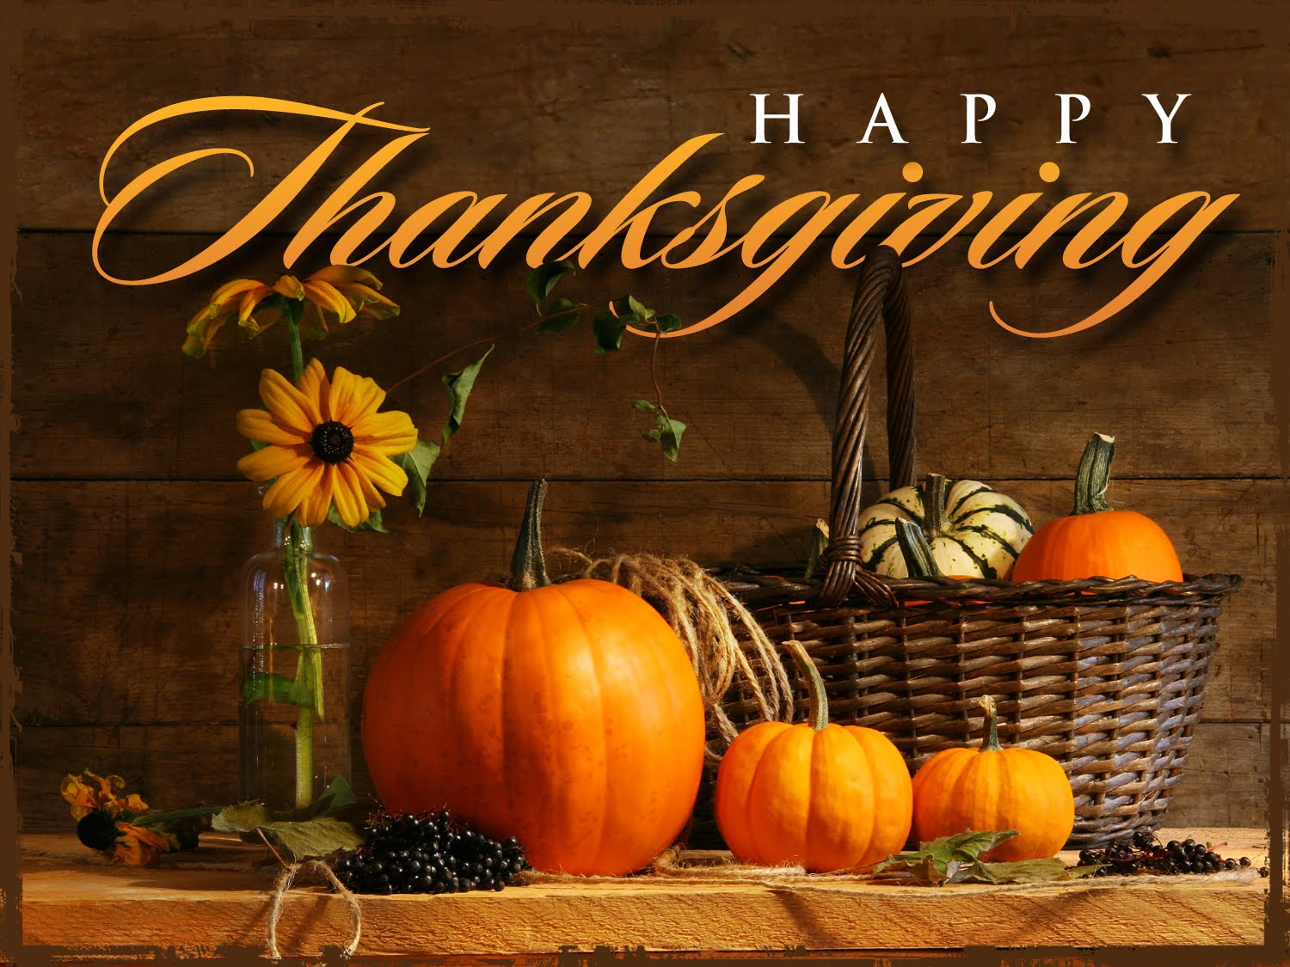

First Reading - Bertha Morgan

Second Reading- Pina Machhiavello

Gospel Reading - Deacon Juan C. Carnero

Homily – Fr. Brando Ibarra

Entrance Song

Let All Things Now Living

1. Let all things now living A song of thanksgiving.
To God our creator triumphantly raise;
Who fashioned and made us, Protected and stayed us,
By guiding us on to the end of our days.
God’s banners are o’er us, Pure light goes before us,
A pillar of fire shining forth in the night:
Till shadows have vanished and darkness is banished,
As forward we travel from light in to Light.

2. His law he enforces, The stars in their courses,
The sun in its orbit obediently shine,
The hills and the mountains, The rivers and fountains,
The depths of the ocean proclaim God divine.
We, too, should be voicing Our love and rejoicing
With glad adoration, a song let us raise:
Till all things now living Unite in Thanksgiving,
To God in the highest, hosanna and praise.

Glory to God

Refrain:

Glory to God, glory to God, glory to God in the highest.
And on earth peace, on earth peace to people of goodwill.
Amen

- We praise you, we bless you, we adore you, we glorify you, we give you thanks for your great glory, Lord God heavenly King, O God almighty Father. (Refrain)

- Lord, Jesus Christ, Only Begotten Son, Lord God Lamb of God, Son of the Father, you take away the sins of the world, have mercy on us; you take away the sins of the world, receive our prayer; you are seated at the right hand, the right hand of the Father, have mercy on us. (Refrain)

- For you alone are the Holy One, your alone are the Lord, you alone are the Most High, Jesus Christ, with the Holy Spirit in the glory of God the Father. (Refrain)

First Reading:

Responsorial Psalm: Blessed be the name of the Lord forever

- Praise, you servants of the Lord, Praise the name of the Lord. Blessed be the name of the Lord both now and forever.

- From the rising to the setting of the sun is the name of the Lord to be praised. High above all nations is the Lord; above the heavens is his glory.

- Who is like the Lord, our God, Who is enthroned on high and looks upon the heavens and the earth below?

- He raises up the lowly from the dust; From the dunghill he lifts up the poor, with the princes of his own people.

Second Reading:

Gospel Acclamation:

Alleluia, Alleluia, Alleluia, Alleluia

Cantor: Give thanks to the Lord who is good.
The Love of the Lord knows no ending.
All in Israel say: “God’s love has no end”.

Gospel Reading:

Homily: Rev. Fr. Brando Ibarra

Offertory Song

COME TO THE FEAST

Refrain:

Ven, ven al banquete.
Ven a la fiesta de Dios.
Here the hungry find plenty,
Here the thirsty shall drink.
Ven a la cena de Cristo
Come to the feast.

- Like the child whose fishes and loaves
Fed the multitude
In the Lord the little we have
Broken and shared
Becomes abundant food. (Refrain)

- Till the seed is given to earth,
It is just one grain;
But one sown its death brings new birth,
The harves is rich;
What’s lost is raised again. (Refrain)

- In the stranger by our side
In the least and last,
In the thirst for justice we share,
Christ is here in the breaking of the bread. (Refrain)

Holy

Holy, holy, holy, Lord God of Hosts.
Heaven and Earth are full,
Are full of your glory.
Hosanna! Hosanna! Hosanna in the highest.
Blessed is he who comes,
Who comes in the name of the Lord.
Hosanna! Hosanna! Hosanna in the highest.

Let us proclaim the Mystery of Faith:
When we eat this Bread
And drink this Wine
We proclaim your Death, O Lord.
Until you come again. (2X)

Doxology

Amen, Amen, Amen (2X)

Our Father

Lamb of God

1. Jesus, Lamb of God,
you take away the sins of the world,
Have mercy on us.
2. Jesus, Bread of Life,
you take away the sins of the world,
Have mercy on us.
3. Jesus, Cup of Hope,
you take away the sins of the world,
Grant us peace.

Communion Songs

ALL MY DAYS

Refrain:

Till the end of my days, O Lord,
I will bless your name,
Sing your praise,
Give you thanks,
All my days.

1. You have made me little less than a god,
and have lavished my heart with your love.
With dignity and honor you have clothed me,
given me rule over all.

2. You have blessed me with good things and plenty
and surrounded my table with friends.
Their love and their laughter enrich me;
together we sing your praise.

3. Your sun and your moon give me light,
and your stars show the way through the night.
Your rivers and streams have refreshed me.
I will sing your praise.

4. How great is your love, O Father,
that you sent us your Savior Son.
His death and his rising will heal us,
and draw us all unto you.

Song after Communion

How Great Thou Art
1. O Lord my God, when I in awesome wonder
consider all the worlds Thy hands have made,
I see the stars, I hear the rolling thunder,
Thy pow’r thru out the universe displayed!
Refrain:

Then sings my soul, my Savior God, to Thee;
How great Thou art, How great Thou art!
Then sings my soul, my Savior God, to Thee;
How great Thou art, How great Thou art!
2. When thru the woods and forest glades I wander,
And hear the birds sing sweetly in the trees,
when I look down from lofty mountain grandeur
And hear the brook and feel the gentle breeze.
3. And when I think that God, His Son not sparing,
Sent Him to die, I scarce can take it in.
That on the cross, my burden gladly bearing,
He bled and died to take away my sin!

