**Communion**: **Praise and Thanksgiving**

1. Praise and thanksgiving, Father we offer, For all things living You have made good. Harvest of sown fields, Fruits of the orchard, Hay from the own fields, Blossom and Wood.

2. Lord, bless the labor We bring to serve you, That with our neighbor we may be fed. Sowing or tilling, we would work with you, Harvesting, milling, For daily bread.

3. Father, providing Food for your children, Your wisdom guiding Teaches us share. One with another, So that rejoicing with us, all others May know your care.

4. Then will your blessing Reach every people, Freely confessing Your gracious hand. Where you are reigning No one will hunger, Your love sustaining, Fruitful the land.

**Taste and See**

Refrain:

Taste and see, taste and see the goodness of the Lord. O taste and see, taste and see the goodness of the Lord, of the Lord.

1. I will bless the Lord at all times. Praise shall always be on my lips; my soul shall glory in the Lord for God has been so good to me.

2. Glorify the Lord with me. Together let us all praise God’s name, I called the Lord who answered me; from all my troubles I was set free.

3. Worship the Lord, all you people, You’ll want for nothing if you ask. Taste and see that the Lord is good; in God we need put all our trust.

**Thanks Be to You**

1. Praise to you, O God of mercy! Thanks be to you for ever! Raising high the weak

and lowly: Thanks be to you forever!

2. From of old you loved and sought us! Thanks be to you forever! Truth and justice

you have taught us: Thanks be to you forever!

3. Strong is your faithfulness, strong is your love, remembering your covenant of life

with us. (Repeat #1)

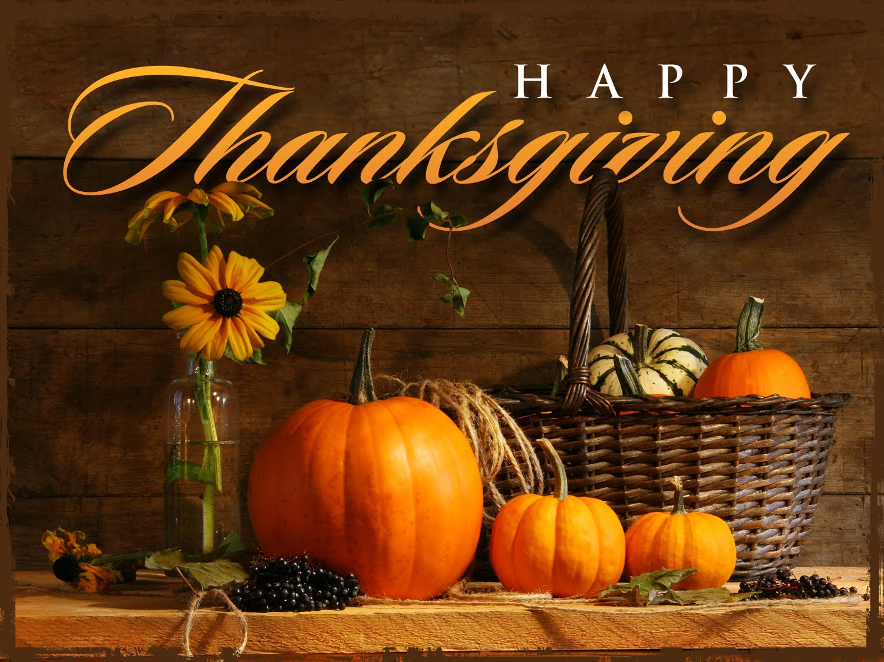

Choir

**Alay Awit Chorale**

Terry Bautista * Nino Lacuesta

(Conductor) (Organist)

First Reading - Bertha Morgan

Second Reading- Pina Machhiavello

Gospel Reading - Deacon Juan C. Carnero

**Homily – Fr. Brando Ibarra**

St Mary Help of Christians Church

**Thanksgiving Mass**

November 26, 2015

10:00 A.M.

A Trilingual Mass

(English, Spanish, Italian)

**Rev. Brando Ibarra,**

**Main Celebrant**

### Entrance Song: **Let All Things Now Living**

### 1. Let all things now living A song of thanksgiving. To God our creator triumphantly raise; who fashioned and made us, Protected and stayed us, by guiding us on to the end of our days. God’s banners are o’er us, Pure light goes before us, A pillar of fire shining forth in the night: Till shadows have vanished and darkness is banished, As forward we travel from light in to Light.

### 2. His law he enforces, The stars in their courses, The sun in its orbit obediently shine, The hills and the mountains, The rivers and fountains, The depths of the ocean proclaim God divine. We, too, should be voicing Our love and rejoicing with glad adoration, a song let us raise: Till all things now living Unite in Thanksgiving, To God in the highest, hosanna and praise.

### Gloria . . .

First Reading

### Responsorial Psalm: Blessed be the name of the Lord forever

1. Praise, you servants of the Lord, Praise the name of the Lord. Blessed be the name of the Lord both now and forever.

2. From the rising to the setting of the sun is the name of the Lord to be praised. High above all nations is the Lord; above the heavens is his glory.

3. Who is like the Lord, our God, Who is enthroned on high and looks upon the heavens and the earth below?

4. He raises up the lowly from the dust; from the dunghill he lifts up the poor, to seat them with princes, with the princes of his own people.

Second Reading

### Gospel Acclamation: Alleluia (4X)

### Verse: Give thanks to the Lord who is good. The Love of the Lord knows no ending. All in Israel say: “God’s love has no end”. (Repeat refrain)

Gospel Reading: **A READING FROM THE HOLY GOSPEL ACCORDING TO LUKE**

As Jesus continued his journey to Jerusalem, he traveled through Samaria and Galilee. As he was entering a village, ten persons with leprosy met him. They stood at a distance from him and raised their voices, saying: “Jesus, Master! Have pity on us!” And when he saw them, he said: “Go show yourselves to the priests.” As they were going they were cleansed.

And one of them, realizing he had been healed, returned, glorifying God in a loud Voice, and he fell at the feet of Jesus and thanked him. He was a Samaritan. Jesus said in reply, “Ten were cleansed, were they not? Where are the other nine? Has none but this foreigner returned to give thanks to God? Then he said to him, “Stand up and go, your faith has saved you.”

**THE GOSPEL OF THE LORD.**

### Homily

### Offertory: **How Great Thou Art**

### 1. O Lord my God, when I in awesome wonder consider all the worlds Thy hands have made, I see the stars, I hear the rolling thunder, Thy pow’r thru out the universe displayed!

### Refrain:

### Then sings my soul, my Savior God, to Thee; How great Thou art, How great Thou art! Then sings my soul, my Savior God, to Thee; How great Thou art, How great Thou art!

### 2. When thru the woods and forest glades I wander, And hear the birds sing sweetly in the trees, when I look down from lofty mountain grandeur And hear the brook and feel the gentle breeze.

### 3. And when I think that God, His Son not sparing, Sent Him to die, I scarce can take it in. That on the cross, my burden gladly bearing, He bled and died to take away my sin!

### 4. When Christ shall come with shout of acclamation and take me home, what joy shall fill my heart! Then I shall bow in humble adoration and there proclaim, my God How Great Thou Art!

------------------

### Holy, Holy, Holy Lord God of Hosts. Heaven and Earth are full of your glory. Hosanna! Hosanna! Hosanna in the highest. Blessed is he who comes, who comes in the name of the Lord. Hosanna! Hosanna! Hosanna in the highest.

### When we eat this Bread and drink this Cup, We proclaim your death O Lord. Until you come again.

### Amen, Amen, Amen . . .

### Our Father. . .

### Lamb of God

### 1. Jesus, Lamb of God, you take away the sins of the world, have mercy

### on us.

### 2. Jesus, Bread of Life, you take away the sins of the world, have mercy

### on us.

### 3. Jesus, Cup of Hope, you take away the sins of the world, grant us

### peace.